**Tugas10**

**(PENGGUNAAN LIBRARY)**



**Disusun Oleh :**

Arief Nauvan Ramadha

Junior Web Developer A

**PELATIHAN VSGA**

**JUNIOR WEB DEVELOPER**

**DIGITAL TALENT SCHOLARSHIP**

**2021**

**Proses instalasi Dompdf**

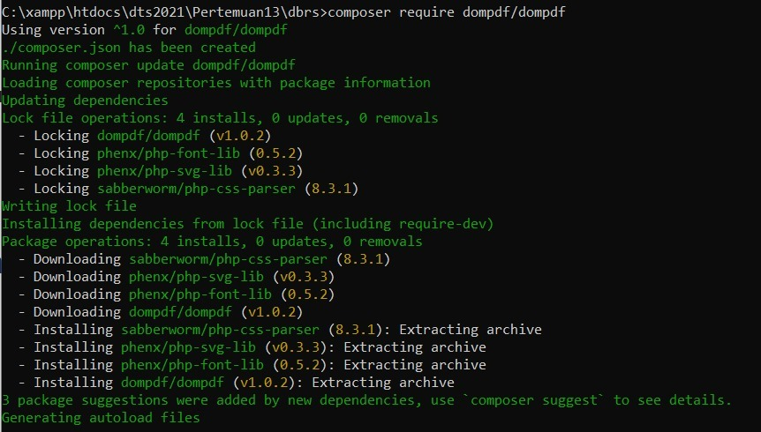

**Source code implementasi library :**

<?php

require ('vendor/autoload.php');

use Dompdf\Dompdf;

$dompdf = new Dompdf();

$kodeHTML = '<div style=" margin-left: 10%; font-family: Arial, Helvetica, sans-serif;">

    <h3 tyle="align: center; margin-top: 5%;">Data Anggota Dokter</h3>

    <table border="1" style="border-collapse: collapse; width: 500px;">

        <tr style="height: 30px; background-color: #007BFF;">

            <td><b>No.</b></td>

            <td><b>Id</b></td>

            <td><b>Nama</b></td>

            <td><b>Jenis Kelamin</b></td>

            <td><b>Alamat</b></td>

            <td><b>Spesialis</b></td>

        </tr>

        <tr>

            <td><b>12</b></td>

            <td><b>AG021</b></td>

            <td><b>Arvandha</b></td>

            <td><b>Pria</b></td>

            <td><b>Jl. Brantas No.21</b></td>

            <td><b>Paru-paru</b></td>

        </tr>

    </table>

 </div>';

$dompdf->loadHtml($kodeHTML);

$dompdf->setPaper('A4' . 'landscape');

$dompdf->render();

ob_end_clean();

$dompdf->stream('Kartu Anggota.pdf');

 ?>

**Hasil :**

